

2 – Hardware Fundamental:

* Computers have 2 parts: Hardware and Software
* Hardware is the physical components of a computer that store and run instructions from software.
* 4 of the main components: input, output, processing, and memory

**Hardware components:**

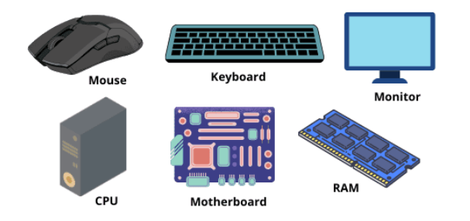

**CPU:**

* CPU: Central Processing Unit
* ALU: Arithmetic Logic Unit
* CU: Control Unit
* Memory Unit: RAM

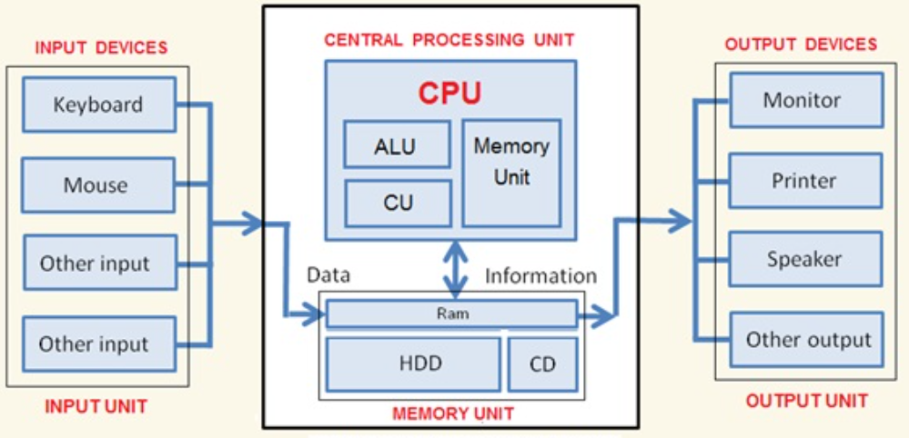



**Hardware components:**

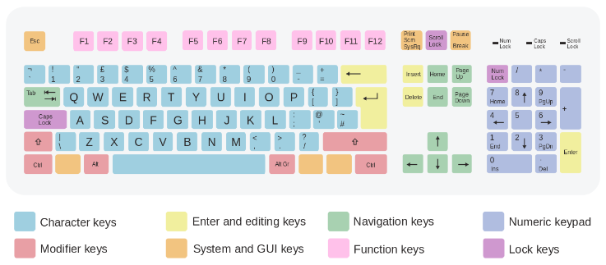

**Hardware components:**

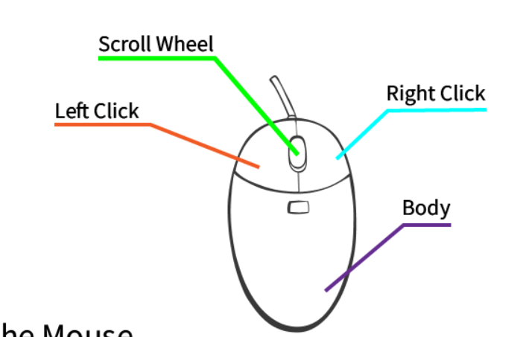



**Computer Memory:**

* Computer memory is any physical device, used to store data, information, or instruction temporarily or permanently.
* RAM: Random Access Memory
* SRAM: Static RAM
* DRAM: Dynamic RAM
* NVRAM: Non-volatile RAM
* BRAM: Block RAM
* FRAM: Ferroelectric RAM
* ROM: Read-Only Memory
* PROM: Programmable ROM
* EPROM: Erasable Programmable ROM
* EEPROM: Electrically Erasable Programmable ROM
* NVM: Non-Volatile Memory 🡪 retain stored information even power is remove



**Types of memory:**

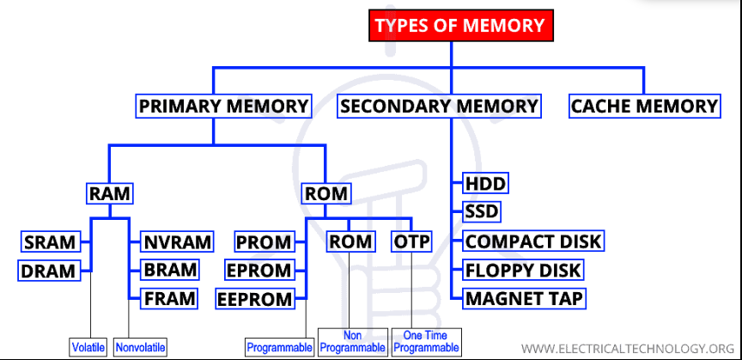



**RAM vs ROM:**

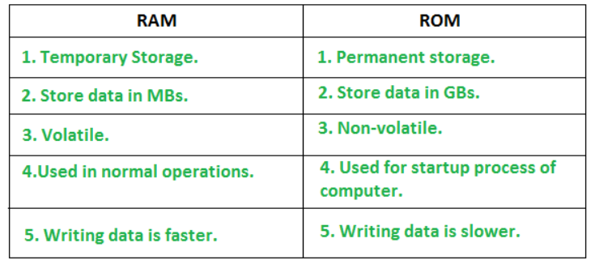

**SRAM vs DRAM:**

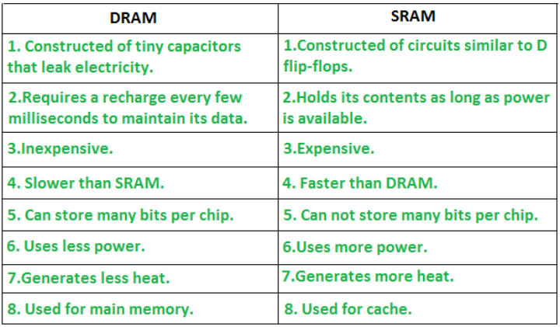



**Cache Memory:**

* A small-sized type of volatile computer memory that provides high-speed data access to a processor and stores frequently used computer programs, applications, and data.

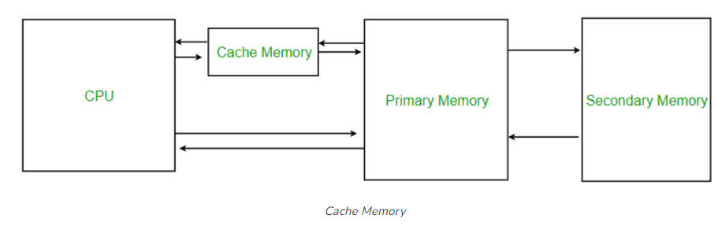

**SSD vs HDD:**

* SSD: Solid-state drive 🡪 C drive (windows run here)
* HDD: Hard disk drive

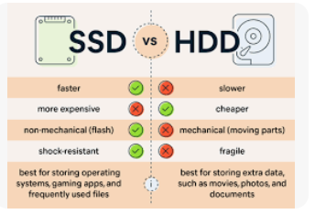

**Memory vs Storage:**

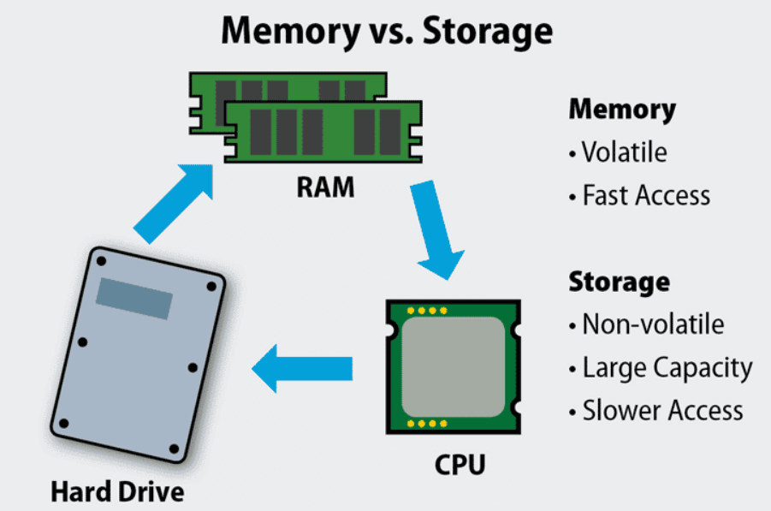



**Memory vs storage:**

